**Quick guide on GBD interface for standard users**

After having specified each aspect of the query in the results tool, as below, select ‘download CSV’.

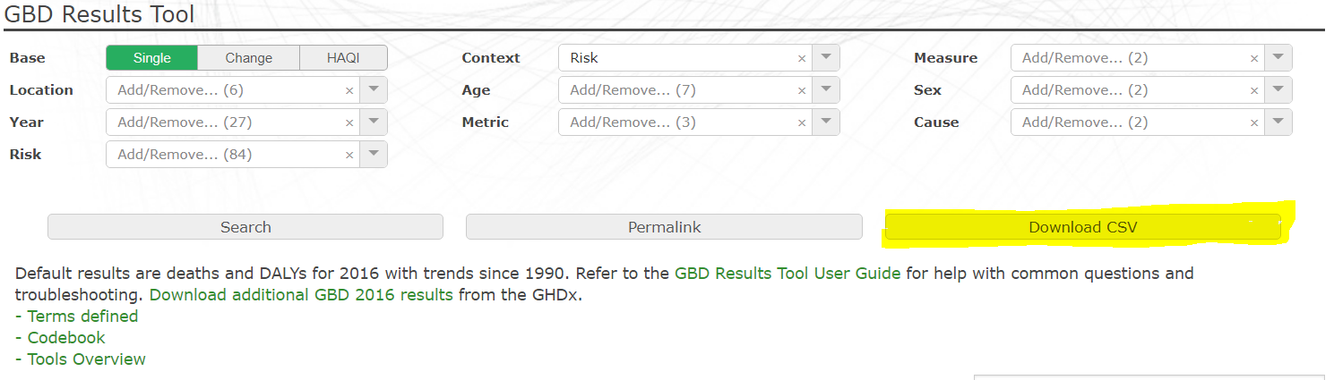

Then select the ‘both’ option (numeric lookups as well as names). The codebook (link above) include hierarchical breakdowns of risk/cause/location categories and so on. These can be used to select only level 1/2/3/ groups so long as the numbers are provided. If in doubt err towards overinclusivity of categories (‘select all’) . E.g. see all 84 risk groups are selected here, even though they are clearly hierarchical not mutually exclusive:

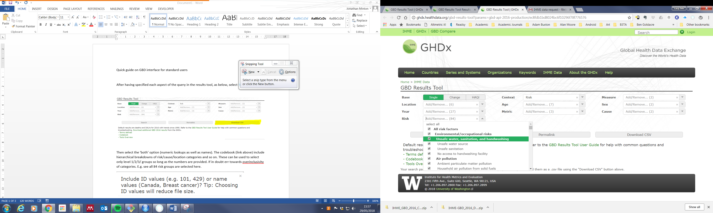

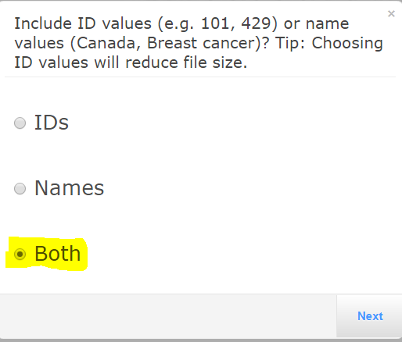

Select multiple files. Enter an email address for when request is complete.

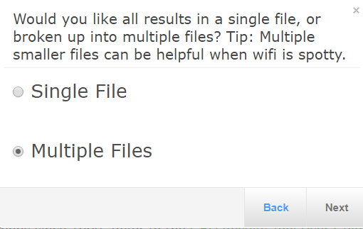

The ‘monitor progress’ link

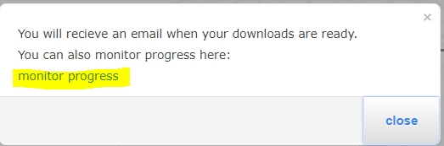

will take you to something like the following.

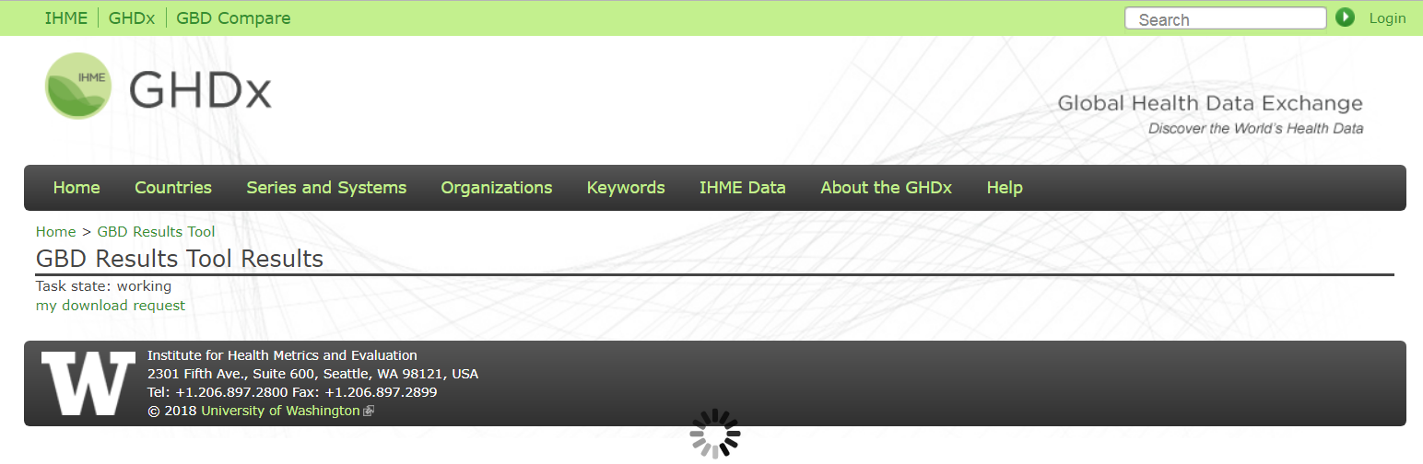

Once the request is completed it should look as follows:

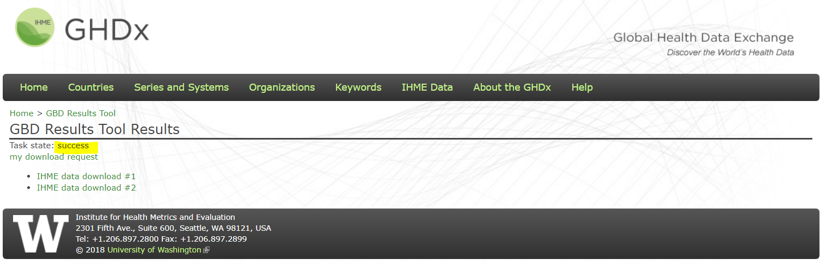

The link addresses are as follows:

<http://s3.healthdata.org/gbd-api-2016-production/ec8fdb1bd8024bc6f10296f78f776576_files/IHME-GBD_2016_DATA-ec8fdb1b-1.zip>

<http://s3.healthdata.org/gbd-api-2016-production/ec8fdb1bd8024bc6f10296f78f776576_files/IHME-GBD_2016_DATA-ec8fdb1b-2.zip>

*Note URLs are identical except for number at the end.*

A script I’ve written downloads these files directly from the URLs, unzips them, then saves as CSV files in an appropriate location.

Note also that the request status is now ‘success’ rather than in progress.

Once the request is completed an email like the following will be sent. Please forward to me.

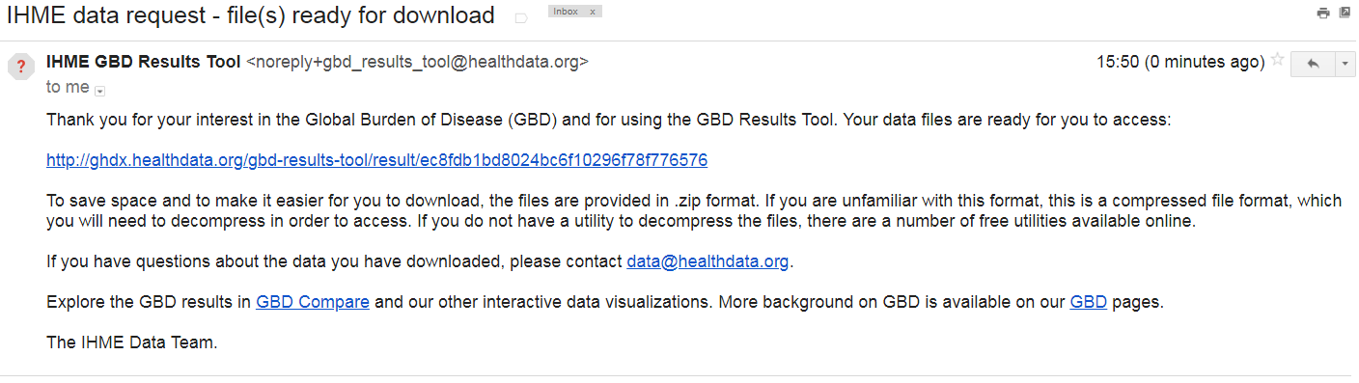

A permalink option is also available:

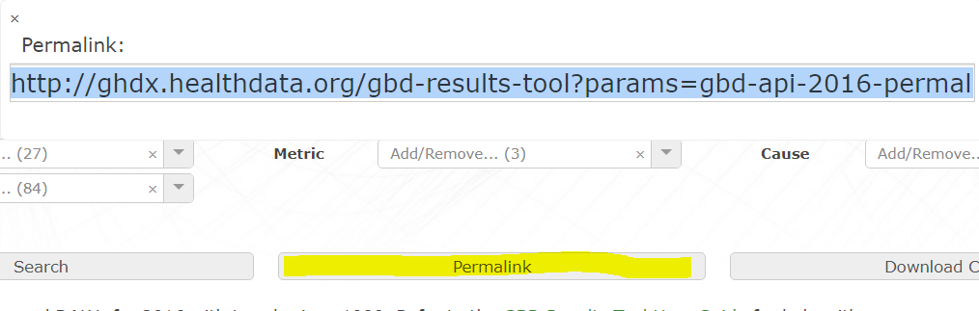

http://ghdx.healthdata.org/gbd-results-tool?params=gbd-api-2016-permalink/669b28aebf8638ac14c759742b7248bf

This can be copied and also sent to me.